**User Manual**

The finished product is called Flash Fire (FINAL) on GitHub and

Flash Fire (FINAL SCRATCH) in group work under the Goebel Berg file and found in the Scratch file.

Press Play Button:

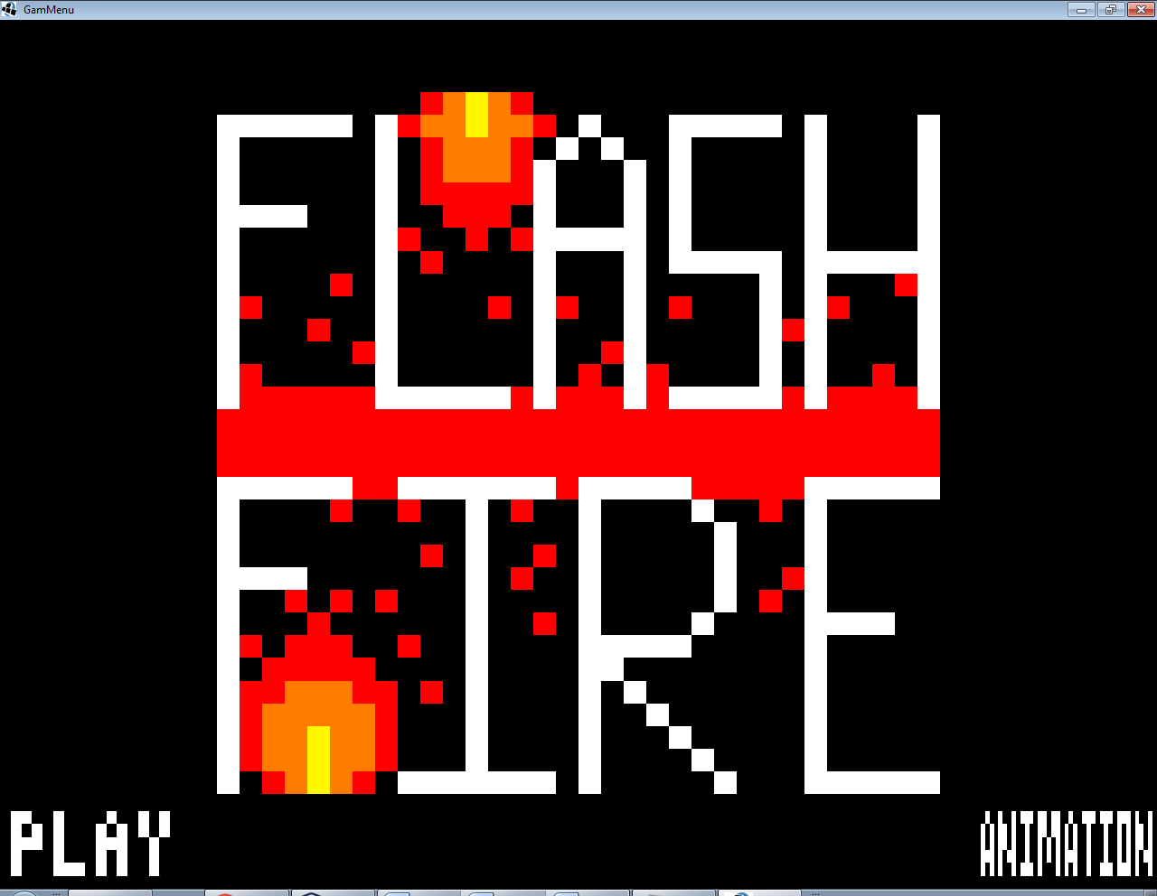

WASD to move Hero (Red Fire Guy):

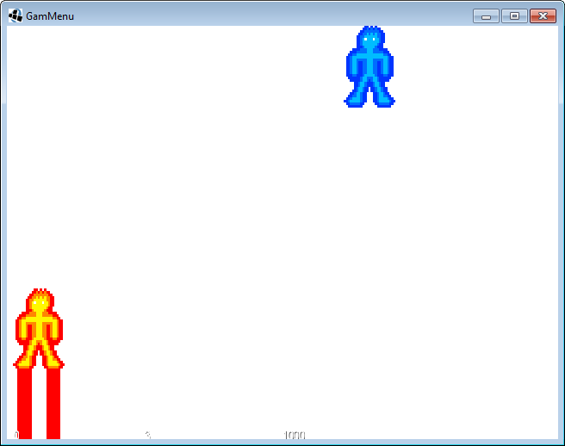

Press Left or Right key to shoot:

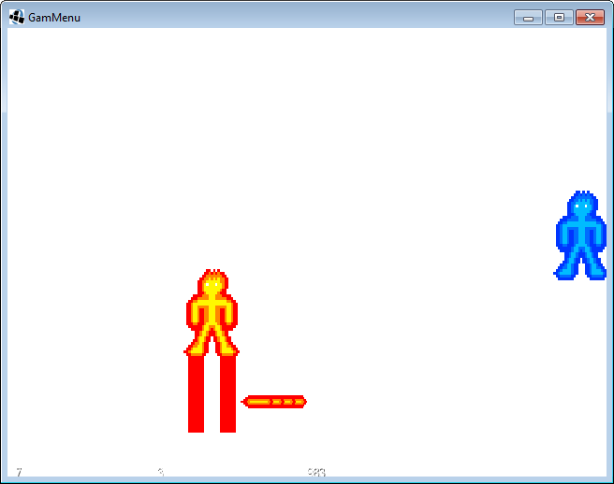

Shoot enemy to gain points:

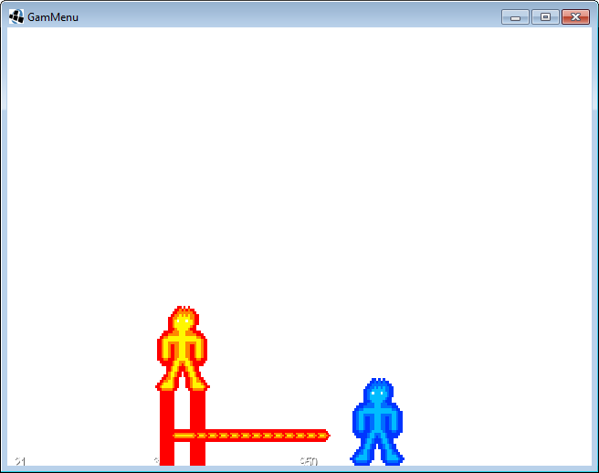

Points appear here

(The 21 in the bottom left)